Code Breaker : Impossible Mission
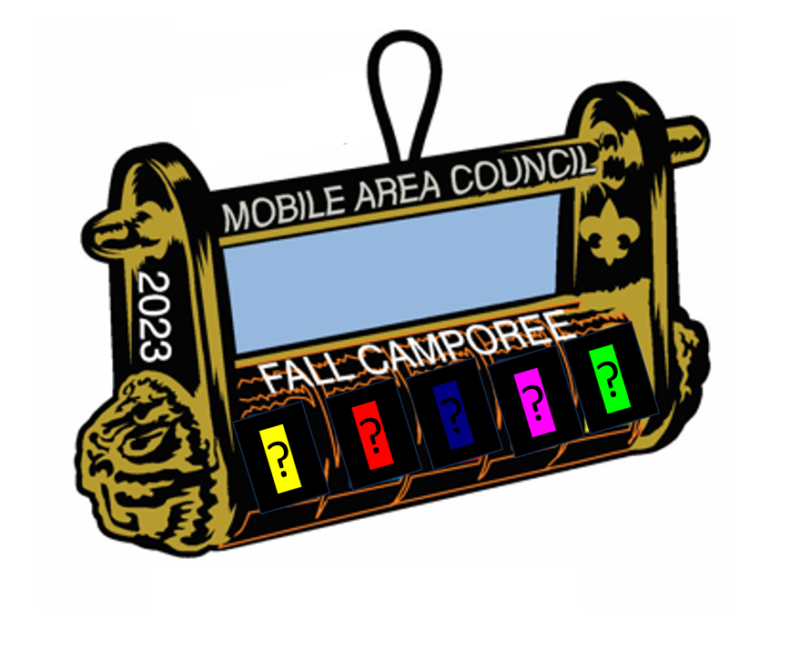

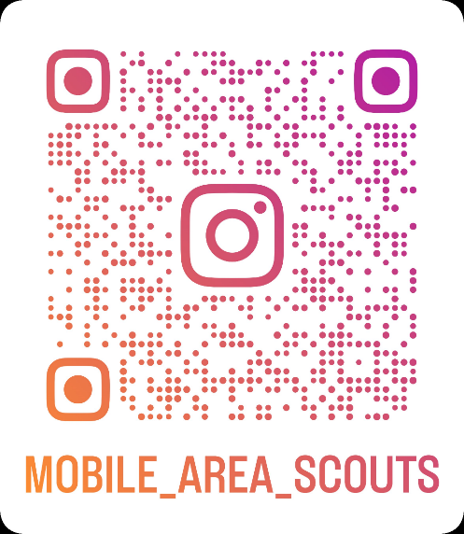
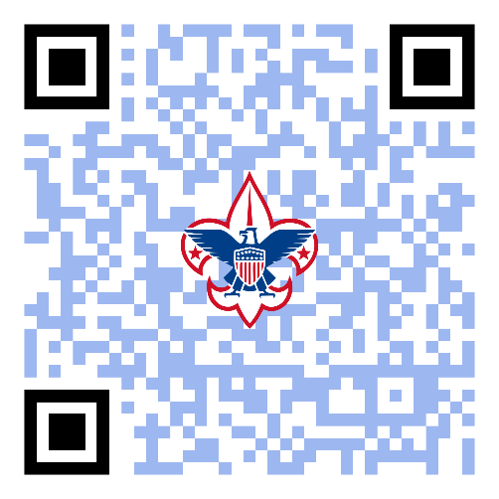
5 RIVERS FALL CAMPOREE

Recover downed satellite balloon/drone’s BLACK BOX
(and open it)

Friday

18:00 Friday Night / REGISTRATION (ARRIVE IN CLASS A)

Check-In (by patrol):
Main gain, directed to Trading Post
Each patrol reports in with their Patrol (country) name, numbers, etc. – assigned camp site.
- WELCOME PACKET –
- MAP / CLUEs to their campsite/, Latitude/longitude - First test to locate campsite?
https://www.fiverr.com/inbox/aimanmalik1994?source=order_page

18:00-20:00 | Brandon? | Entrance
18:30-2030 |  | Trading Post |  | Video Loop – Status of downed drone and background information
19:00 – 21:00 |  | Campsites

ADULT LEADERS – Registration

( Brandon, ? Ward, Rick )

Trading Post
18:30
- VIDEO #1 at TRADING POST

21:00 Briefing in Dining Room

VIDEO #2 at Background video/news? As scouts enter – video/news loop?

ADULT LEADERS – Dining Hall
Video | Henry Parker
Registration -CIA Team | Rick Griffen
Camp Directors? | FRI: Coach Emily
Snacks/Presentation  Cracker barrel food etc | Renee Laboe
 | Brad Philips

CIA Representative (MR X) presents:
- Three days ago, two autonomous UAV’s, (like unmanned balloons) one named Ursa Major and the other Ursa Minor, were performing surveillance missions, collecting essential information in the airspace above the Republic of Bacpakistan. Then without warning we lost contact with Ursa Major.
- Satellite imagery indicates Ursa Major lost contact with controllers over this area (Visual). To protect U.S. interests, its sister aircraft, Ursa Minor has been grounded indefinitely. Ursa Major had enough fuel to travel approximately 250 kilometers considering wind and other factors.
- We have estimated that the UAV probably crashed in the following area ----…-----.
- Ladies and Gentlemen, we have leads that terrorist organizations, as well as other potentially hostile foreign nations want to get their hands on the information contained in the black box aboard Ursa Major.
- One of the operatives was dispatched to the 24 hours ago, but we have lost contact. We believe the operative left clues.

- VIDEO #3 at related to MISSION, old fashion mission impossible

Your Mission, if you choose to accept it: Locate the missing black box recorder before it falls into enemy hands and its contents is used to destroy the Free World.

CIA Representative (MR X) presents:

Once patrols are trained, under the cover of darkness, on Saturday night we will use this map, and investigate this area. Follow instructions carefully.

We are scoring patrols on performance – like top gun – looking for the best patrol for the mission ; each of the skills / training will help develop four key areas which we think will be necessary to complete your mission

We are training you on a variety of exercises/skill to hone FOUR key areas
- Teamwork
- Strength
- Puzzle Solving
- Endurance

We will be scoring you Realtime score We will update you throughout the day with real-time scores (Lunchtime/Dinnertime)

- VIDEO #4 at SCORE SHEET?

Then, Saturday Night, the top scoring patrols will be sent to search and decode the black box

So, For tonight – here’s a recap for tonight

- Training on code breaking concepts (Dining Hall) with Food
  - Night hike – traversing trail in stealth mode

? VIDEO CLIP OF TRAINING??

21:30-23:00 Dining Room – and Hike

This is basically a set of 8 stations. A buzzer will go off every 10 minutes

Adult Leaders/Troops Helping -Friday Night Welcome/During Cracker-barrel

Puzzles/Games:
Doug Phillips, Charlene Doll, Shaun Small, Howard Horne, April Smith, Will Gates, Bob Collins)

During Friday night: goal Is get the scouts to look at things and question everything Is It a puzzle, a challenge? a clue?

5 mission impossible movie shows

Station 0a - Training Stations

1 | Gummy Bears | Charlene | Using the different colors and numbers of gummy bears, deduct a code number
2 | Escape Room Fundamentals | Shaun | Plus example of using playing cards to deduct a code number
3 | Where am I? | Bob | 4 maps, 4 codes (pig pen, binary, morse, braille), deduct the hinted location on the map
4 | Ciphers | Doug | Examples of ciphers: Shift, Block, Keyword, Substitution
5 | Numbers | Will | 7 segment display puzzle
6 | Written in Knots  ? mayan numbers? | Howard | Deduce a code based on how knots are tied
7 | Blacklight/Invisible Ink | Christian
8 | Morse Code | Donnie
9 | Hike | Jerome

Station 0-b - FULL MOON HIKE

(Jerome Swan, Coach Emily, Joey Butler, Andrew Woodward)

STATION |  | SESSION (Every 10 minutes) Starts at 21:30
 |  | 1 | 2 | 3 | 4 | 5 | 6 | 7 | 8
 |  | 2130-2140 | 2140-2150 | 2150-2200 | 2200-2210 | 2210-2220 | 2220-2230 | 2230-2240 | 2240-2250
 | 1 | Group 1 | Group 8 | Group 7 | Group 6 | Group 5 | Group 4 | Group 3 | Group 2
 | 2 | Group 2 | Group 1 | Group 8 | Group 7 | Group 6 | Group 5 | Group 4 | Group 3
 | 3 | Group 3 | Group 2 | Group 1 | Group 8 | Group 7 | Group 6 | Group 5 | Group 4
 | 4 | Group 4 | Group 3 | Group 2 | Group 1 | Group 8 | Group 7 | Group 6 | Group 5
 | 5 | Group 5 | Group 4 | Group 3 | Group 2 | Group 1 | Group 8 | Group 7 | Group 6
 | 6 | Group 6 | Group 5 | Group 4 | Group 3 | Group 2 | Group 1 | Group 8 | Group 7
 | 7 | Group 7 | Group 6 | Group 5 | Group 4 | Group 3 | Group 2 | Group 1 | Group 8
 | 8 | Group 8 | Group 7 | Group 6 | Group 5 | Group 4 | Group 3 | Group 2 | Group 1

23:00
Cracker barrel

Saturday

Overview: Training exercises to develop skills necessary. Earn Clues to help with Saturday night; scouts will not know what they are trying to earn nor will they know how or when if it is useful for instance

Morning
06:00 – Scouts eat breakfast at campsite
08:00 – Flag ceremony & Saturday Camp Director Announcement; CLASS B ALL WEEKEND UNTIL DEPARTURE

08:30 – 12:20 Morning Training sessions start (see map) 40 minutes each
- Blind Folded Group Team work– will be an area that is heavily monitored and patrols will need to work together to navigate along the course in complete darkness – and silence, while avoiding detection
- Obstacle Course – This will test and build patrol’s Endurance and Teamwork and simulate navigating in the terrain expected to be encountered during the retrieval.
- Satellite imagery indicates that some of bridges were washed out. Again, you will improvise and relying on your training to build a bridge, if needed
- Find Mystery Code/Puzzle – The operatives who went in ahead of you, were trained to leave ‘breadcrumbs’ along their path that are encrypted so only ‘our side’ can decipher; we will teach you techniques to encrypt and to decipher coded hidden messages.
- Laser/avoid enemy detection

 | Location and setup | Session 1  0830-0915 | Session 2  0920-10:00 | Session 3  10:05-1045 | Session 4  1050-1130 | Session 5  1135-1220
Blind-folded (1)  Kim Baum  Jerome Swan Sr.  Charles Martin | near training center  2x | Group 1 | Group 5 | Group 4 | Group 3 | Group 2
Obstacle Course (2)  Rick Griffen  Robert (Bob) Collins  Hendrik Snow | climbing wall  1x | Group 2 | Group 1 | Group5 | Group 4 | Group 3
Bridges (3)  Freddie O'Neal  Lee Smee  Pete Haring | Scout Skills  2x | Group 3 | Group 2 | Group 1 | Group 5 | Group 4
Mystery Code/Puzzle  Jason Farmer  Tommy McPherson?  Charles Harris  Howard Horne  David Jarrell | Handicraft  1x | Group 4 | Group 3 | Group 2 | Group 1 | Group 5
Laser  Kevin West  Pete Wert  Barry Cupp | STEM LAB  1x | Group 5 | Group 4 | Group 3 | Group 2 | Group 1

Lunch
12:30 Saturday Lunch break for lunch in dining hall. NO time to waste going to camp site.
Call it a working/learning lunch. UPDATES from camp director, X and with video info.
JAWS OF DEATH – You will exercise your jaws on a buffet This is a light meal served buffet style scheduled midway through the day for everyone to enjoy.
It serves a few purposes.
  - First it refuels young bodies.
  - It serves as a midpoint where staff can check everyone's status.
  - Is everyone accounted for?
  - Are there any injuries?
  - Are the events/missions going smoothly?

VIDEO/UPDATE SCORES

? VIDEO CLIP OF TRAINING??

Movies in background

145 First round scores will be announced.

Saturday Lunch Adult Leaders

Renee Laboe, Brad Philips, Henry Parker, Chuck Kelley

SATURDAY Afternoon
14:00-17:00 Escape rooms, First Aid/Rescue, Team Building, Waterfront
6 Captured: If you get captured, you may need to use decipher / look for clues to escape the room.
7. Emergency Medical Transport: In the event you come across our first-line agents injured – or if one of your patrol gets injured – we will review emergency medical and evacuation procedures
8 Group team building activities: you may be working with new units / patrols and need to quickly integrate as a team and function smoothly.
9. Lake There are several areas that have flooded due to changing weather conditions-creating lakes and rivers that are new. We have no boats available. The location of the bodies of water is unpredictable. You will need to think outside of the box and work with available resources.

 |  | Session 6  14:00-14:45 | Session 7  14:50-15:25 | Session 8  15:30-16:15 | Session 8  16:20-1700
Escape Room (6)  (Easier) (Standard)  Doug Phillips  Shaun Small  Kevin West  Charlene Doll  Kim Baum  Will Gates | Junior Staff  3x | Group 1 | Group 4 | Group 3 | Group 2
Rescue (7)  Freddie O'Neal  Andy Givens  Phillip Abernethy  Jason Dabbs  David Jarrell | Scout Skills  1x | Group 2 | Group 1 | Group 4 | Group 3
Team Building  Jason Coym  April Smith  Andrew Woodward | Chapel  1x | Group 3 | Group 2 | Group 1 | Group 4
Waterfront (9)  Coach Emily  Joey Butler  Clint Padgett | Lake  1x | Group 4 | Group 3 | Group 2 | Group 1

SATURDAY Evening
17:15-1900 (at campsite) Scouts eat Dinner
19:00 Return to dining room
Camp director indicates which patrol is searching for the black box
19:05: guest visit campsite and explain rules
19:15-20:30 “MISSION IMPOSSIBLE : RECOVER DOWNED DRONE”
Dinner back at Troop camp area 5:00 - 6:30
7:00 Meet In dining room: Video Footage Score update
Announcement of patrols that will go on MISSION

Black Box Search and Recovery: 7:00 - 8:30
RECAP
- A reconnaissance plane has gone down over enemy territory. The pilot is a high-level intelligence officer who has knowledge of our covert operations. The patrol must act as a search and rescue team to find him, treat him for injuries if necessary, and transport him back to the station. You must find him quickly before someone else does.
- During today’s training exercises, patrols learned about codes/deciphering – and may have earned a clue

20:30 – Scouts arrive in Arena for Campfire with box

Scouts arrive at arena with their specific black box
We wait for all scouts to return or until 21:35 (siren)
Black box is locked
(on black box, in black light sensitive ink- are clues) (if scouts use black light flashlight) like COLOR CIPHER
Patrols are handed envelopes containing ‘flash-card’ like color ciphers with 14 letters
Once Letters are arranged it will spell out
Loyal or scout or brave or clean

So, the letters (with color cipher) we will include will be
A, E, L, Y, O, L, S, C, U, T, B, V, R, N

Scouts can create at least these 4 5-letters words to open up black box
Inside the box – patches and cany – patches glow-in the dark
Loyal or scout or brave or clean

20:45 – CODE BREAKING
22:00 – SKITS

MISSION: Recover Black Box and Decipher Code – Station 10

Make / BLACK BOXES * mark brown has ordered lock and box
(Lawrence Specker, Doug Phillips, Hannah Ashbee, Mark Brown)

22:45 Scouts return to Dining hall
22:45 Cracker barrel

(Renee Laboe, Brad Phillips, Henry Parker)

Sunday AM
0800: Flag ceremony
0900: Service/awar

